Initial Page View:

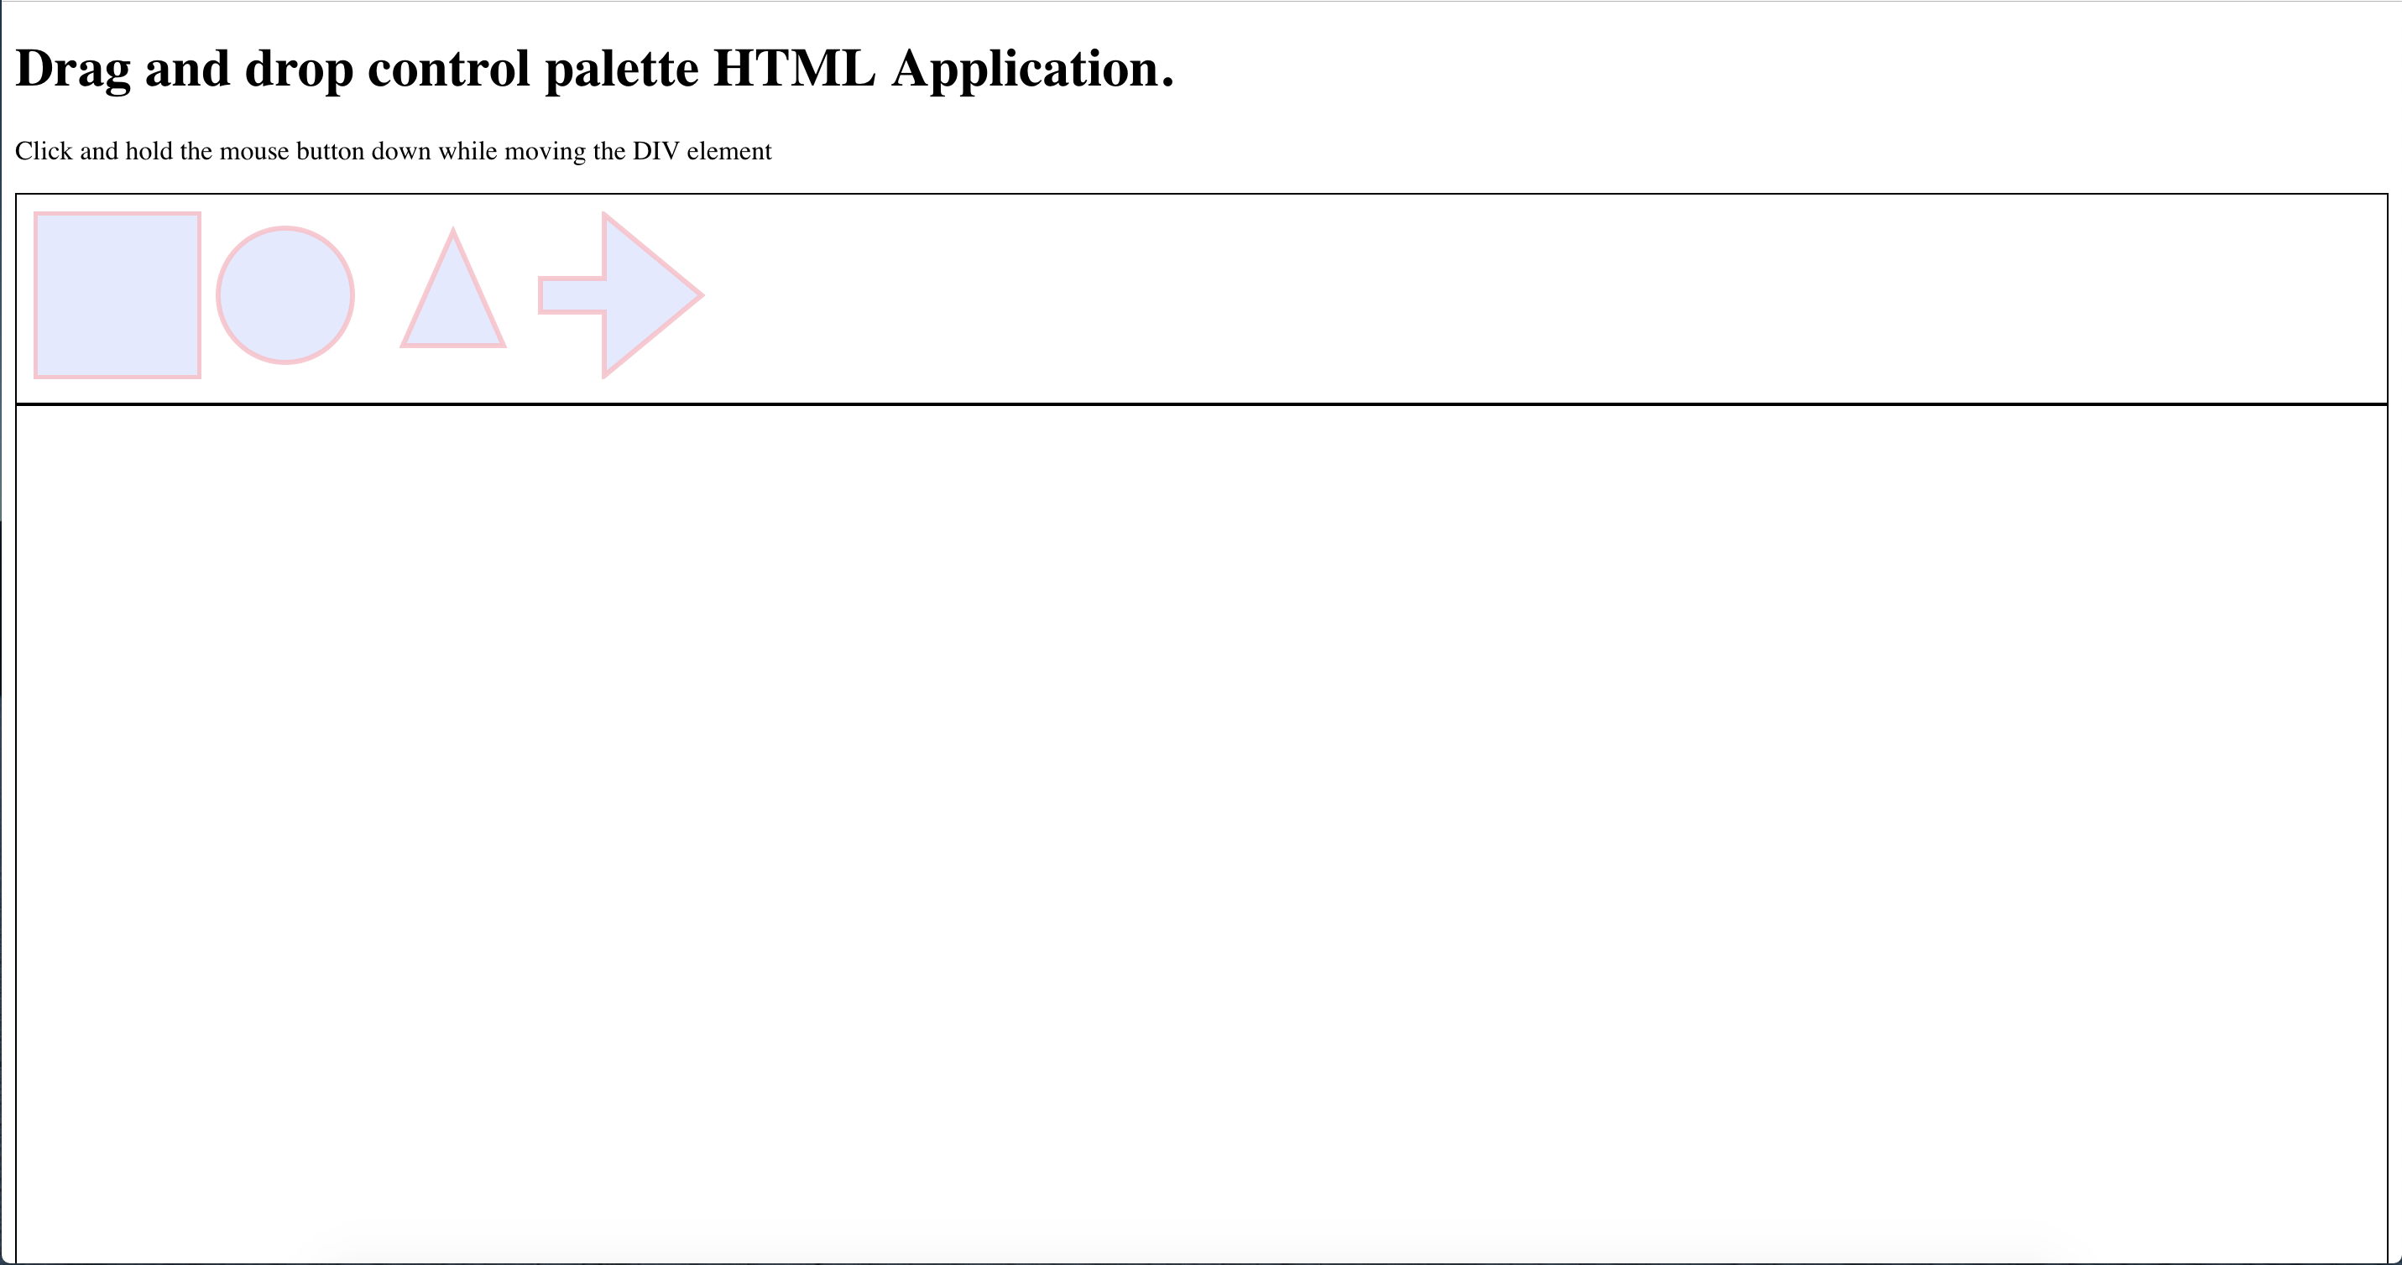

Dragged SVG element view (Element is not dropped yet):

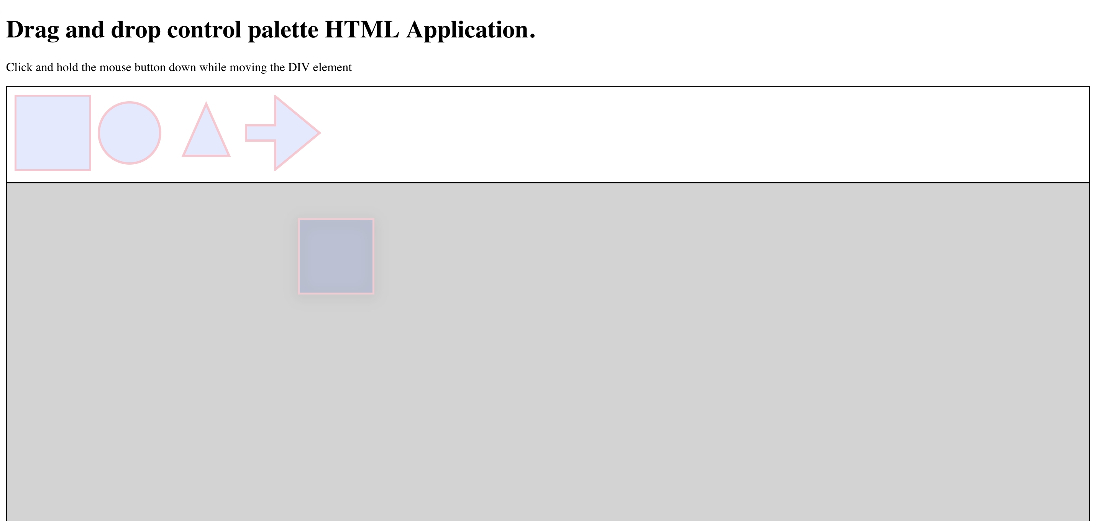

View after dropping multiple elements(Elements can be rearranged):

